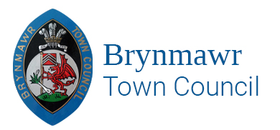
BRYNMAWR TOWN COUNCIL’S TRAINING PLAN
Purpose
The council has a statutory duty under section 67 of the Local Government and Elections (Wales) Act 2021 to make a plan setting out what it proposes to do to address the training needs of its councillors and staff.
The purpose of the training plan is designed to ensure that collectively, councillors and staff, have the knowledge and awareness needed for the council to operate effectively. It is not necessary for all councillors and staff to have received the same training and develop the same expertise.
A new training plan must be put in place after each ordinary election of community councillors to reflect the training needs resulting from changes to the council membership and to provide for the election of new councillors. This is the council’s first training plan but hereinafter it will review the plan from time to time to keep it up to date and relevant.
A record of all training accessed will be maintained by the Clerk.
Staff Training
All new staff to take Induction Training | As and when required
All office-based staff encouraged to undertake the following, for which the Council will provide financial support:  - ILCA – Introduction to Local Council Administration.  - FILCA – Financial Introduction to Local Council Administration.  - CILCA – Certificate in Local Council Administration. | On going
All Staff encouraged to read regular publications and update from internet Websites:  - SLCC  - The Clerk  - OVW | Monthly
All Staff encouraged to attend training relevant to their position | On going

Council
Council to allocate a training budget to cover provision of training publications for members & staff. | Annually

Councillors’ Training
All Councillors are provided with New Members Induction Pack following Local Council Elections as soon as practicable after the local elections. | Every 4 years
All Councillors are encouraged to complete a skills audit to identify training needs. | Annually
All Councillors shall undertake training in the Code of Conduct within 6 months of the delivery of their declaration of acceptance of the office.  (Standing Order, No 13b). | On Election to Office
All Councillors are encouraged to attend conferences and training events as appropriate to members and Councils needs and responsibilities. | Annually
All Councillors encouraged to read the following publications:  - The Good Councillors Guide  - Governance and Accountability – A Practitioners Guide. | On Election to Office  On the Internet

