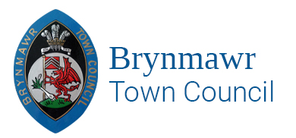

ANNUAL REPORT 2024/2025

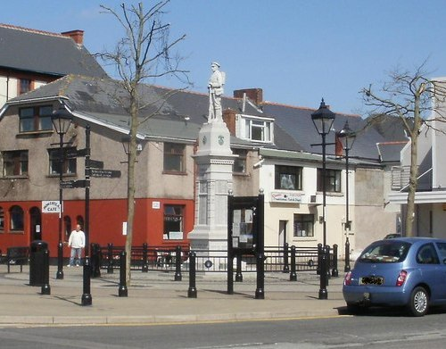

Brynmawr Town Council Contact Details:

email: [clerk@brynmawrtc.co.uk](mailto:clerk@brynmawrtc.co.uk)

Tel: 01495 832309

[**www.brynmawrtc.co.uk**](http://www.brynmawrtc.co.uk)

**Meet our Mayor 2024/2025**

**Councillor W.K. Hodgins.**

About this report

This report sets out the activities, events, donations etc. that the Brynmawr Town Council has/will undertake during the financial year 2024-2025 to contribute to the economic, social and well-being of the town of Brynmawr and its residents. It also provides a brief outline of what the Council does and contact details.

About Brynmawr Town Council

Brynmawr Town Council is the local council for Brynmawr. The Council at present has ten members covering two wards North and South.

Each year in May the Council elects a Mayor who represents the Town Council at events throughout the year. This year 2024-2025 the Mayor is Councillor Wayne Hodgins. The Town Council is supported by a small team consisting of two staff members Mrs, Angela. C. Davies, Town Clerk/RFO and Miss Nicola J. Williams, Assistant Town Clerk who are based in the Brynmawr Institute, Market Square, Brynmawr, Ebbw Vale NP23 4AJ.

The Town Council gets almost all its funds from its precept. This is an additional amount added to the Council Tax bills based on the Town Council’s estimated expenditure. For the Financial year 2024/2025 the Council’s precept was £45,000.00. Brynmawr Town Council’s expenditure includes paying for services, supporting local events, and awarding grants.

The Town Council’s main responsibilities include:

* Awarding grants to local groups and charities.
* Supporting the Scare on the Square event.
* Brynmawr Town Centre Partnership – Switching on Christmas lights event.
* Wales Air Ambulance.
* Purchasing hanging baskets for around the War Memorial.
* Maintaining the War Memorial.
* Supporting local events and festivals.
* Providing free events in the town – Christmas disco, Play days during holidays at the Brynmawr Welfare Park.
* Rent and maintain the Brynmawr Allotments Gardens.
* Fund local food banks.
* Award a grant towards Armistice Day refreshments.
* Donate each year to the Earl Haig Poppy Appeal.

 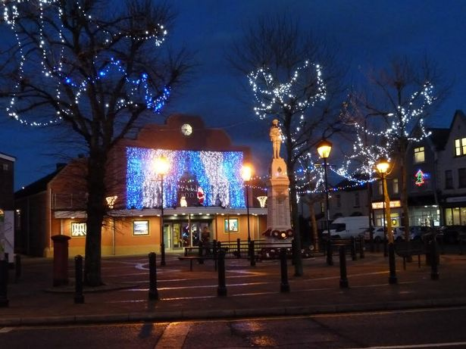 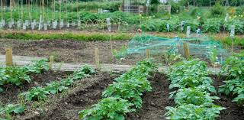

So, what have the Town Council accomplished from April 2024?

Celebrated D-Day 80th Anniversary on Sunday, 09 June 2024.

The event commenced with the Brynmawr Veterans along with attendees and residents holding a two-minute silence followed by laying a Wreath at the Brynmawr War Memorial.

After the formalities there were two military vehicles present, face painter, Mascot, and free refreshments.

Free Town Council Events which contribute to the Adults, Children and

Young People of Brynmawr Town.

This year the Brynmawr Town Council have established an events Committee where all members of the Town Council meet and discuss events they would like to hold throughout the year. The D-day Event held was the first of hopefully many events the Town Council will hold to bring residents together.

The Town Council will be holding something for the children during the School Holidays possibly a summer disco with face painter which is yet to be confirmed.

Brynmawr Christmas Disco –The Brynmawr Town Council Christmas Disco will take place at the Brynmawr Social Club during the month of December where the children receive a free selection box, and the adults receive a raffle ticket to win a prise.

Many of our Councillors including staff are school Governors and continue to support the development of these schools.

Planning

Brynmawr Town Council has a Planning & Urgent Matters Committee takes place during the end of Full Council Meetings which consists of all Members of the Council and the minutes are discussed and approved at the following meeting. Any comments and objections are then forwarded to the Blaenau Gwent County Borough Council.

Finance

Brynmawr Town Council has a Finance Committee which consists of nine Councillors who meets quarterly where applications from various groups/organisations and all other financial correspondence are discussed. Recommendations are presented to the Full Council for approval.

How are we becoming a more responsive Town Council.

The Town Council has a redesigned website which is accessible for most people to use. The Town Council is also going to set up a Facebook page. Information of all Council meetings, Councillors contact details, local information and all reports are available on the website.

Brynmawr Town Council holds regular meetings with the Aneurin University Health Board, Blaenau Gwent Police, Local A.M and P.M and various other organisations and groups.