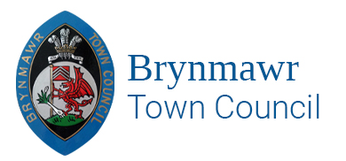

ANNUAL REPORT 2022/2023

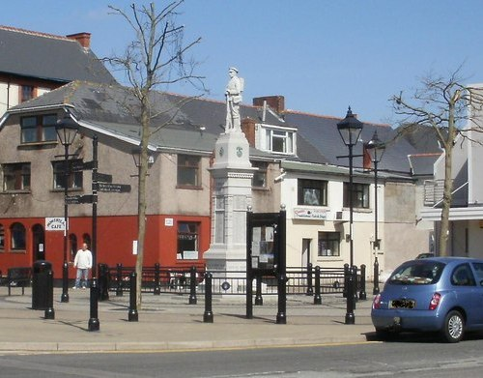

[**www.brynmawrtc.co.uk**](http://www.brynmawrtc.co.uk)

BRYNMAWR TOWN MAYOR 2022-2023

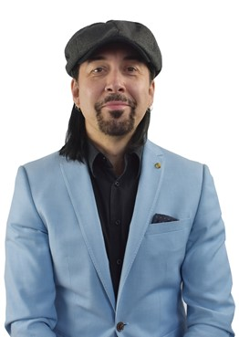**Councillor Julian Gardner**

About this report

This report sets out the activities, events, donations etc. that the Brynmawr Town Council has/will undertake during the financial year 2022-2023 to contribute to the economic, social and well-being of the town of Brynmawr and its residents. It also provides a brief outline of what the Council does and contact details.

About Brynmawr Town Council

Brynmawr Town Council is the local council for Brynmawr. The Council at present has ten members covering two wards North and South.

Each year in May the Council elects a Mayor who represents the Town Council at events throughout the year. This year 2022-2023 the Mayor is Councillor Julian Gardner. The Town Council is supported by a small team consisting of two staff members Mrs, Angela. C. Davies, Town Clerk/RFO and Miss Nicola J. Williams, Assistant Town Clerk who are based in the Brynmawr Institute, Market Square, Brynmawr, Ebbw Vale NP23 4AJ.

The Town Council gets almost all its funds from its precept. This is an additional amount added to the Council Tax bills based on the Town Council’s estimated expenditure. For the Financial year 2022/2023 the Council’s precept was £43,000.00. Brynmawr Town Council’s expenditure includes paying for services, supporting local events, and awarding grants.

The Town Council’s main responsibilities include:

* Awarding grants to local groups and charities.
* Supporting the Scare on the Square event.
* Brynmawr Town Centre Partnership – Switching on Christmas lights event.
* Wales Air Ambulance.
* Purchasing hanging baskets for around the War Memorial.
* Maintaining the War Memorial.
* Supporting local events and festivals.
* Providing free events in the town – Christmas disco, Play days during holidays at the Brynmawr Welfare Park.
* Rent and maintain the Brynmawr Allotments Gardens.
* Fund local food banks.
* Award a grant towards Armistice Day refreshments.
* Donate each year to the Earl Haig Poppy Appeal.

 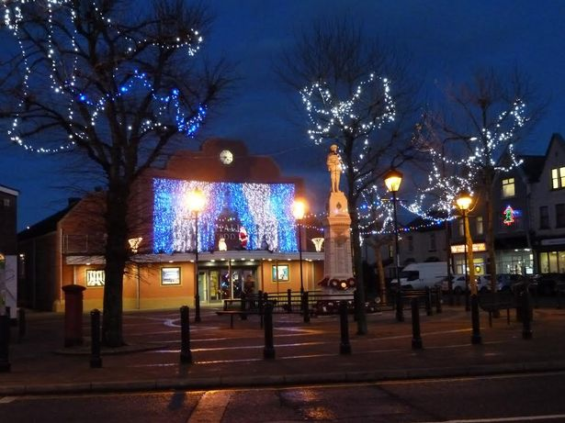 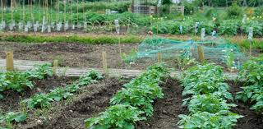

So, what have the Town Council accomplished from April 2022?

The Brynmawr Town Council has erected a Memorial Stone dedicated to the memories of residents who have tragically lost their lives due to Covid at the Welfare Park, Brynmawr.

**BRYNMAWR TOWN COUNCIL**

**TO COMMEMORATE THOSE WHO DIED FROM THE “COVID 19” VIRUS**

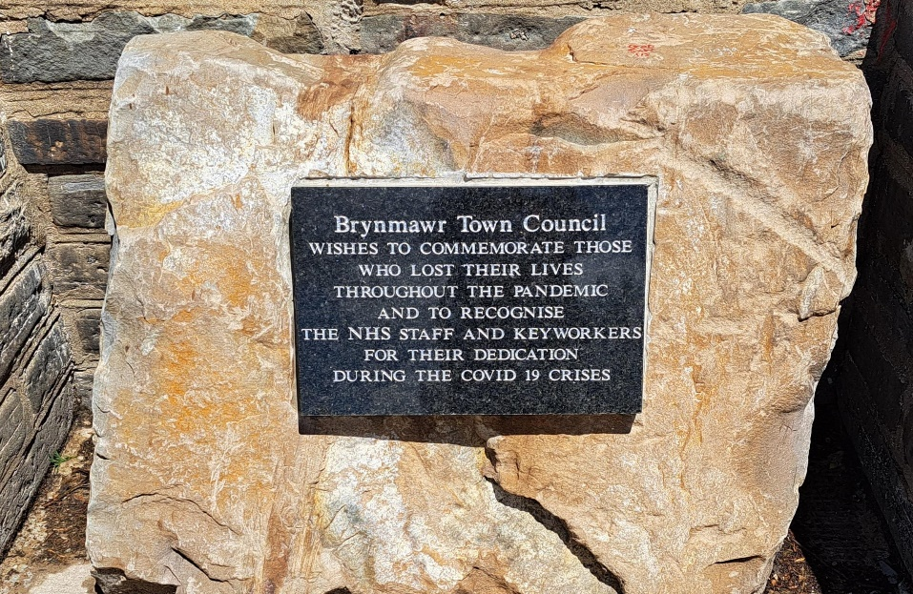

The stone will be unveiled by Councillor Julian. M. Gardner (Town Mayor) date to be confirmed at the old water fountain site in the Welfare Park, Brynmawr.

The stone plaque has been carved and engraved with the following words: “***Brynmawr Town Council wish to commemorate the people who lost their lives throughout the pandemic and to recognise the NHS Staff and keyworkers for their dedication during the Covid 19 crises.”***

The Brynmawr Town Council wanted to create a symbol somewhere prominent where people can pay their respects.

**Brynmawr Town Council**

**Unveiling of her Majesty's Queen Elizabeth**

**Platinum Jubilee Plaque**

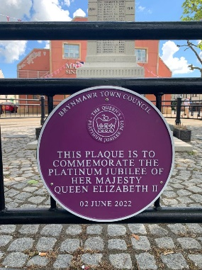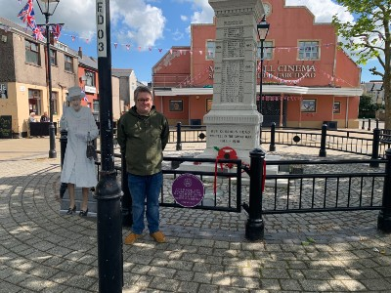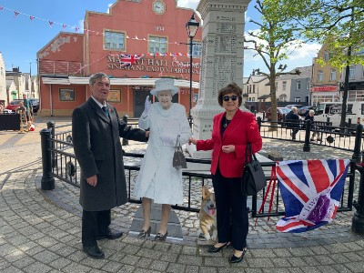

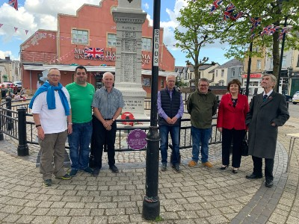On Tuesday, 2 June 2022 Councillor Andrew Talbot (Deputy Mayor) unveiled her Majesty’s Queen Elizabeth Platinum Jubilee Plaque purchased and erected by the Brynmawr Town Council to mark the event. Numerous Brynmawr Town Councillors, BGCBC Councillors and members of the public turned up to witness and celebrate the unveiling of the Platinum Jubilee Plaque.

Free Town Council Events which contribute to Children and Young People.

Each year the Brynmawr Town Council fund Play Sessions during the holidays held at the Welfare Park, Brynmawr.

Brynmawr Christmas Disco – due to Covid the Town Council Christmas disco has not taken place for the past couple of years but fingers crossed we will be able to hold one in December 2022.

Many of our Councillors including staff are school Governors and continue to support the development of these schools.

Planning

Brynmawr Town Council has a Planning & Urgent Matters Committee which consists of nine Councillors who meets monthly and makes recommendations to the Full Council where the minutes are discussed and approved. The comments and objections are then forwarded to the Blaenau Gwent County Borough Council.

Finance

Brynmawr Town Council has a Finance Committee which consists of nine Councillors who meets quarterly where applications from various groups/organisations and all other financial correspondence are discussed. Recommendations are presented to the Full Council for approval.

How are we becoming a more responsive Town Council.

The Town Council has a redesigned website which is accessible for most people to use. The Town Council is also going to set up a Facebook page. Information of all Council meetings, Councillors contact details, local information and all reports are available on the website.

Brynmawr Town Council holds regular meetings with the Aneurin University Health Board, Blaenau Gwent Police, Local A.M and P.M and various other organisations and groups.

Brynmawr Town Council erected a Blue Plaque to commemorate the late Mr. Roy Francis at the Brynmawr Rugby Club, Catholic Road, Brynmawr.

Mr. Roy Francis was born in [Brynmawr](https://en.wikipedia.org/wiki/Brynmawr), South Wales (20 January 1919 – April 1989). He was a Welsh [rugby union](https://en.wikipedia.org/wiki/Rugby_union), and professional [rugby league](https://en.wikipedia.org/wiki/Rugby_league) footballer and [coach](https://en.wikipedia.org/wiki/Coach_(sport)) of the mid-20th century.

He was the first [Black British](https://en.wikipedia.org/wiki/Black_British) professional coach in any sport. He played [rugby union](https://en.wikipedia.org/wiki/Rugby_union) for [Brynmawr RFC](https://en.wikipedia.org/wiki/Brynmawr_RFC) before joining English [rugby league](https://en.wikipedia.org/wiki/Rugby_league) club [Wigan](https://en.wikipedia.org/wiki/Wigan_Warriors) as a seventeen-year-old  on 14 November 1936.

